# Exception

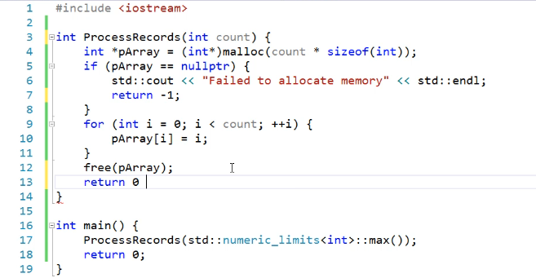

**Memory Allocation and Error Handling**

**Traditional Return Value Method**

1. **Memory Allocation**:

* Functions often need to allocate memory dynamically.
* Typically, they return a value indicating success or failure.

1. **Limitations**:

* The caller might ignore the return value.
* This can lead to unnoticed errors and unhandled exceptions, compromising the robustness of the program.

**Exception Handling as a Solution**

1. **Forcing Error Handling**:

* Exception handling ensures that errors cannot be ignored.
* If a function like processrecords() fails, it throws an exception.

1. **Benefits**:

* The caller is forced to handle the exception, ensuring that the error is acknowledged.
* Leads to more reliable and maintainable code.
* Enhances the robustness of the program by making **error handling mandatory.**

**Summary**

Using exceptions, we can make error handling more robust. When functions like processrecords() throw exceptions upon failure, the caller must handle these exceptions, ensuring that all errors are properly addressed and increasing the reliability of the code.

# How Exception Write and work

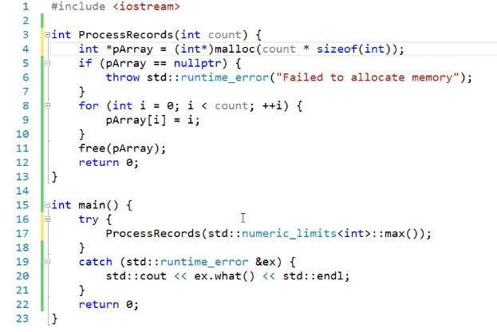

**Using Exception Handling for Robust Error Management**

**Throwing an Exception**

1. **Throwing an Exception**:

* Instead of printing an error message, throw an exception using the throw statement.
* Construct a runtime_error exception object with an error message string.
* Remove any return -1 statements since control will not return to the point after the exception is thrown.

1. **Example**:

**Handling the Exception**

1. **Unhandled Exceptions**:

* If an exception is thrown and **not caught, the program will crash**.
* To prevent this, exceptions must be caught and handled properly.

1. **Using try and catch Blocks**:

* Place the call to processrecords() inside a try block.
* Follow it with a catch block to handle runtime_error exceptions by reference.

1. **Example**:

1. **Explanation**:

* The try block contains the code that may throw an exception.
* The catch block handles the exception, printing the error message using the what() method.
* what() is a virtual function in the std::exception class, providing more information about the exception.

**Benefits of Exception Handling**

1. **Forcing Error Handling**:

* Ensures that exceptions cannot be ignored.
* Forces the caller to handle errors, leading to more robust and reliable code.

1. **Control Flow**:

* When an exception is thrown, control exits the processrecords() function immediately.
* Control then jumps to the corresponding catch block in main() or any other calling function.

1. **Flexible Error Handling**:

* Within the catch block, decide what actions to take (e.g., logging, cleanup, retry mechanisms).

**Summary**

By throwing exceptions and handling them with try and catch blocks, we can ensure robust error management. This forces the caller to address errors, preventing them from being ignored and leading to more reliable and maintainable code. The what() method provides detailed error messages, which can be used for debugging and logging.

**Handling Multiple Exceptions in C++**

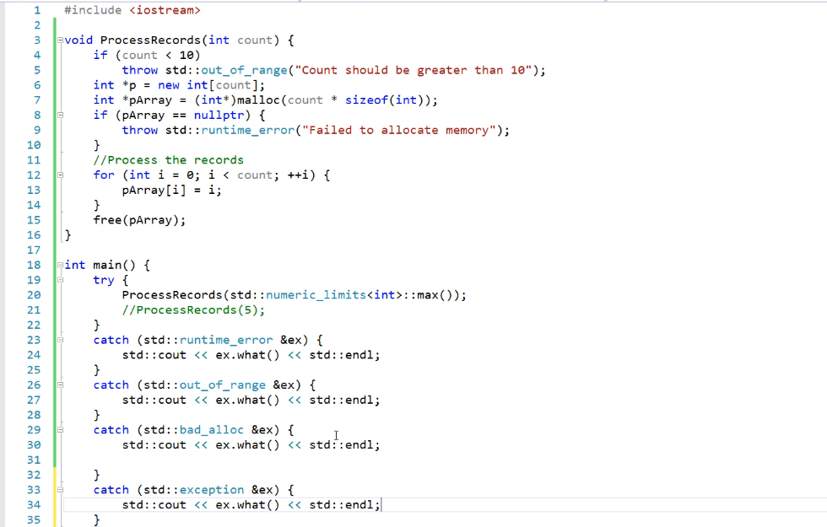

**Throwing and Catching Exceptions**

1. **Throwing Exceptions**:

* Use throw statements within a try block to signal errors.
* Each specific condition can throw a different type of exception.

1. **Example**:

**Handling Exceptions**

1. **Using try and catch Blocks**:

* Wrap the function call in a try block.
* Provide corresponding catch blocks for each possible exception.

1. **Example**:

1. **Explanation**:

* The try block contains the code that may throw exceptions.
* Multiple catch blocks handle different types of exceptions.
* The catch block for **std::exception** serves as a **general** handler for any exceptions derived from std::exception.

**Important Notes**

1. **Multiple Exceptions**:

* A try block can throw multiple types of exceptions.
* Each thrown exception should have a corresponding catch block.
* If no matching catch block is found, the program terminates due to an unhandled exception.

1. **Specificity of Catch Blocks**:

* The catch blocks **should be ordered from most specific to most general**.
* This ensures that exceptions are caught and handled appropriately.

1. **Exception Type Hierarchy**:

* In C++, **all standard exceptions inherit from std::exception.**
* This allows a **generic catch block** to handle all exceptions derived from std::exception.

**Example with Multiple Exceptions**

1. **Condition-Based Exception**:

* If a condition like count being less than 10 is an error, use throw within an if block.

1. **Memory Allocation Failure**:

* Use new for dynamic memory allocation.
* If new fails, it throws a bad_alloc exception.

1. **Catching Specific Exceptions**:

* Handle each specific exception with its own catch block.
* Provide meaningful error messages or recovery actions.

**Summary**

In C++, multiple exceptions can be thrown and handled using try and catch blocks. Each type of exception should have a corresponding catch block to handle it, preventing unhandled exceptions and program termination. Specific exceptions can be caught and handled first, followed by more general exceptions. Using the standard exception hierarchy allows for efficient and organized error handling.

# Std::exception & (…)

**Handling Exceptions Efficiently in C++**

**Unified catch Block**

1. **Single Catch for Multiple Exceptions**:

* Instead of having multiple catch blocks with the same handling code, use a single catch block for all derived exceptions.
* This simplifies the code and reduces redundancy.

1. **Example**:

1. **Explanation**:

* The catch block catches any exception derived from std::exception.
* This unified block handles all exceptions thrown by processrecords(), such as runtime_error and bad_alloc.

1. **Advantages**:

* Simplifies code maintenance.
* Ensures consistent handling of exceptions from various derived classes.

**"All Catch" Block**

1. **Using an Ellipsis (...)**:

* A catch block with ellipsis (...) **catches any type of exception, even those not derived from std::exception.**

1. **Example**:

1. **Explanation**:

* The ellipsis catch block catches any exception not handled by the specific catch blocks.
* It provides a fallback mechanism for unexpected exceptions.

1. **Disadvantages**:

* Lacks information about the caught exception.
* Generally not useful for debugging and should be avoided if possible.

1. **Best Practices**:

* Use specific catch blocks for known exceptions to handle them appropriately.
* Place the "all catch" block at the end to ensure specific exceptions are caught first.

1. **Compiler Warnings**:

* Placing an "all catch" block first may hide specific exception handling and can generate compiler warnings.

**Summary**

* Use a unified catch block to handle multiple exceptions derived from the same base class, ensuring consistent and efficient error handling.
* An "all catch" block (...) should be used sparingly and placed at the end of the catch blocks to act as a safety net for unexpected exceptions.
* Specific catch blocks are recommended for handling known exceptions, providing more detailed and useful error handling logic.

# Stack unwinding

**Understanding Stack Unwinding and Exception Handling in C++**

**Stack Unwinding**

* **Definition**: Stack unwinding is the process that occurs when an exception is thrown in C++. The runtime system unwinds the call stack to ensure that resources are properly deallocated and destructors for local objects are called.
* **Purpose**: Ensures that local objects are properly destroyed and cleaned up when an exception propagates out of a function.

**Limitations of Stack Unwinding**

* **Heap-Allocated Objects**: **Stack unwinding does not handle cleanup for dynamically allocated objects** **on the heap**. If an exception is thrown and the code to deallocate heap memory is bypassed, memory **leaks can occur.**
* **Example**:

In this scenario, if an exception occurs before delete testPtr is executed, the destructor for Test is not called, leading to a memory leak.

**Ensuring Proper Cleanup**

1. **Smart Pointers**:
   * **Usage**: Smart pointers, such as std::unique_ptr and std::shared_ptr, manage the lifetime of dynamically allocated objects. They ensure that objects are properly deallocated when the smart pointer goes out of scope, even in the case of exceptions.
   * **Example**:

1. **Containers**:
   * **Usage**: Containers like std::vector manage dynamic memory allocation and deallocation automatically, reducing the risk of memory leaks.
   * **Example**:

**Benefits of Proper Memory Management Practices**

* **Automatic Cleanup**: Using smart pointers and containers automates memory management, ensuring that resources are properly released even when exceptions occur.
* **Code Readability and Maintainability**: These practices lead to cleaner, more readable, and maintainable code by reducing the complexity associated with manual memory management.
* **Exception Safety**: Smart pointers and containers inherently provide better exception safety, making the code more robust and less prone to memory leaks.

# Problem soultion

# Nested exception

**Nested Exception Handling in a Loop for Record Processing in C++**

Handling exceptions within a loop can be complex, but it is essential to ensure the overall operation remains robust and resilient. Here, we outline a method to handle exceptions within a loop that processes records, while also managing the overall operation.

**Key Concepts**

1. **Try-Catch Blocks**: Wrap the processing of each record in a try block to catch exceptions that occur during processing.
2. **Local Exception Handling**: Handle exceptions locally within the catch block, allowing the loop to continue processing the remaining records.
3. **Tracking Errors**: Keep track of errors encountered during record processing.
4. **Abandoning Operation**: If the number of errors exceeds a threshold, abandon the entire operation by re-throwing the exception.
5. **Modifying Exception Objects**: Modify the caught exception object to add additional information before re-throwing it.
6. **Class Destructor**: Use a class destructor to demonstrate proper resource management, ensuring resources are released correctly.

**Example Implementation**

Here’s a detailed example that integrates the concepts mentioned:

**Explanation**

1. **Try-Catch Blocks**:
   * Each record processing is wrapped in a try block to catch exceptions thrown by processRecord.
2. **Local Exception Handling**:
   * If an exception occurs during the processing of a record, it is caught and handled locally within the catch block.
3. **Tracking Errors**:
   * The errors variable is incremented each time an exception is caught, keeping track of the number of errors encountered.
4. **Abandoning Operation**:
   * If the number of errors exceeds the defined threshold (errorThreshold), a new exception is thrown to indicate that the operation should be abandoned.
5. **Modifying Exception Objects**:
   * Before re-throwing, a new exception with additional information is created and thrown to provide more context about why the operation is being abandoned.
6. **Class Destructor**:
   * The Test class is used to demonstrate resource management, with its destructor ensuring that resources are properly released when an exception occurs.

**Benefits of This Approach**

* **Robustness**: The application can handle errors gracefully, process as many records as possible, and only abandon the operation when necessary.
* **Clarity**: The use of try-catch blocks and error tracking provides clear and maintainable code.
* **Resource Management**: Smart pointers and destructors ensure that resources are managed correctly, avoiding memory leaks and other resource issues.

By using this structured approach, you can effectively manage exceptions within a loop, ensuring that your application remains robust and reliable.

# Exception Handling Constructor & Destructor

Exception handling in constructors and destructors is crucial for managing object initialization and resource acquisition. If a constructor encounters a failure, typically signaled by throwing an exception, object initialization halts and allocated memory is automatically released. However, the destructor is not invoked in this scenario, potentially leading to resource leaks and inconsistent object states if not handled carefully.

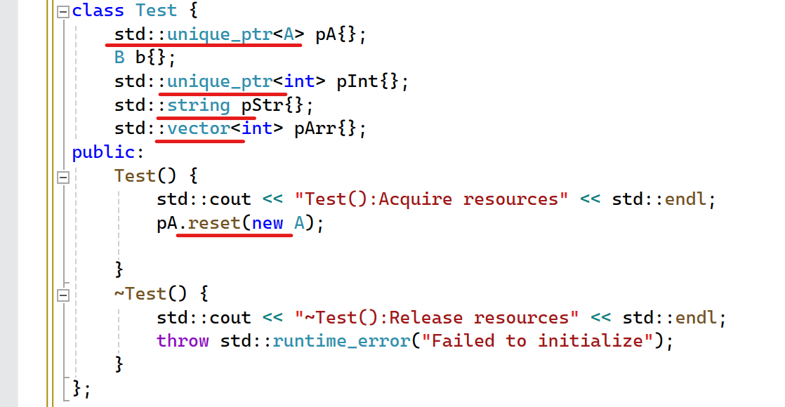

**// Should be avoided**

* **Using smart pointers, vectors, and strings** will manage freeing the memory that has been allocated, probably preventing the problem of memory leaks.
* Using smart pointers as members of your class can help ensure proper resource management even if the constructor throws an exception. This is due to the automatic cleanup provided by smart pointers when they go out of scope.
* Regarding exceptions in destructors. **We should refrain from throwing the exception at the class destractor**. Destructors should avoid throwing exceptions, especially **during stack unwinding**. If a destructor must throw an exception, it should handle it internally to prevent it from escaping and potentially causing program termination. This is essential for maintaining robust error handling and preventing unexpected program termination due to cascading exceptions during stack unwinding.

# Noexcept

* Program will crash

* The "Test()" function does not specify no-except keywords, so it may or may not throw an exception.
* The program will also crash because the "Test()" function that throws an exception is invoked inside the "sum()" function.

**Understanding the noexcept Operator in C++**

The noexcept operator is a powerful feature in C++ that allows developers to specify whether a function is guaranteed not to throw any exceptions. This can be beneficial for optimization and improving code safety by providing guarantees about exception behavior.

**Key Concepts**

1. **noexcept Operator**:

* **Definition**: The noexcept operator checks if an expression can throw an exception. It evaluates to true if the expression is marked as noexcept or cannot throw, and false otherwise.
* **Usage**: Commonly used in function declarations to specify that a function will not throw exceptions.

1. **Consistent Exception Specifications**:

* By using noexcept, you can ensure that related functions have consistent exception specifications, reducing the risk of unexpected behaviors and making the code more robust.

**Example: Applying noexcept to Functions**

In the following example, we demonstrate how to use noexcept to ensure that the Sum() function has the same exception specification as the Test() function.

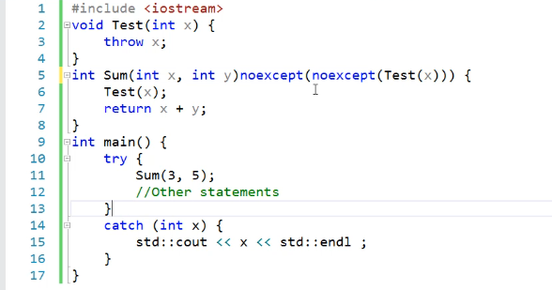

**Explanation**

1. **Defining Test() with noexcept**:

* The Test() function is defined with the noexcept specifier, indicating that it does not throw any exceptions.
* void Test() noexcept { /* Function body */ }

1. **Using noexcept with Sum()**:

* The Sum() function is declared with noexcept(noexcept(Test())). This means the noexcept status of Sum() will be the same as that of Test().
* If Test() is noexcept, then Sum() will also be noexcept.

1. **Checking noexcept at Compile Time**:

* The noexcept operator can be used in expressions to check if a function is noexcept.
* std::cout << "Test() noexcept: " << noexcept(Test()) << std::endl;
* std::cout << "Sum() noexcept: " << noexcept(Sum()) << std::endl;

**Benefits of Using noexcept**

* **Optimization**: Functions marked as noexcept can enable certain compiler optimizations, making code faster and more efficient.
* **Safety**: Ensures that functions will not throw exceptions, reducing the risk of unexpected exceptions causing program termination.
* **Consistency**: Using noexcept to align exception specifications across related functions helps maintain consistency and predictability in exception handling.

**Conclusion**

The noexcept operator is a valuable tool in C++ for managing and optimizing exception safety in your code. By using noexcept, you can ensure that functions are marked correctly, preventing unexpected exceptions and making your programs more robust and efficient.

* In C++, a function cannot be marked as `noexcept` if it calls other functions that are not “noexcept” or performs operations that may throw exceptions, such as invoking library functions with unknown behavior. Therefore, if a function has the potential to throw exceptions, it should be marked as `noexcept(false)` to accurately reflect this possibility.

# Noexcept use case

1. ‎**”noexcept" Specifier:** This specifier indicates that a function will not throw any exceptions during its ‎execution.‎
2. ‎**Destructor in C++11:** In C++11, all destructors are implicitly marked as "noexcept”, which means they ‎are not expected to throw exceptions.‎
3. ‎Usage of "noexcept”: It's essential to mark functions that are sure not to throw exceptions with the ‎‎"noexcept" keyword. This improves code clarity and allows compilers to optimize.‎
4. ‎**Move Operations:** Move constructors and move assignment operators should be marked with ‎‎"noexcept" if they are not expected to throw exceptions. This is crucial, especially when dealing with ‎standard containers like vectors or lists, as they can optimize their operations based on whether move ‎operations are noexcept.‎
5. ‎**Performance Optimization:** By specifying "noexcept" on move operations, you allow containers to ‎utilize move semantics efficiently, improving the performance of operations involving your objects.‎
6. ‎**Guidelines:** For user-defined classes with move operations, it's recommended to use the "noexcept" ‎specifier on those operations to enable optimizations and ensure consistency with standard library ‎containers.‎

Overall, using "noexcept" specifiers appropriately can lead to more efficient and robust code, especially in ‎scenarios involving resource management and move semantics.‎

# Containers like “vector” or “list” prefer move operations over copy operations for efficiency reasons

1. **Efficient Memory Management:** Move operations transfer ownership of resources from one object to another without duplicating the underlying data. This means that instead of copying each element individually, a move operation simply transfers the pointers or handles to the data, which is much faster, especially for large objects or containers with many elements.
2. **Reduced Overhead:** Moving objects typically involves fewer operations and less memory allocation than copying. For containers like `vector` or `list`, which may need to resize or reorganize memory when elements are added or removed, using move operations can significantly reduce the overhead associated with these operations.
3. **Optimized Performance:** Standard library containers are designed to take advantage of move semantics when provided by user-defined types. This means that if a move constructor or move assignment operator is available and marked as `noexcept`, the container can optimize its operations to use moves instead of copies wherever possible, leading to improved performance.

# Mandatory for move operations to have the `noexcept` specifier:

1. **Exception Safety:** Containers like “vector” or “list” need to ensure strong exception safety guarantees. If a move operation throws an exception, it could leave the container in an inconsistent state, leading to potential memory leaks or data corruption.
2. **Optimization Decisions:** Containers make optimization decisions based on whether move operations are marked as “noexcept”. If a move operation is not marked as “noexcept”, the container cannot rely on it to provide strong exception safety guarantees, and therefore may resort to using copy operations instead, which could degrade performance.
3. **API Contracts:** By marking move operations as “noexcept”, the class is making a commitment to the standard library containers and other users of the class that these operations will not throw exceptions. This allows containers to make informed decisions about optimization strategies and ensures consistent behavior across different platforms and implementations.

In summary, providing `noexcept` on move operations not only ensures strong exception safety guarantees but also enables containers to optimize their performance by preferring move operations over copy operations.